

School of Computer Science and Information Technology

Department of Computer Science and Information Technology

Semester: 2nd MCA
Specialisation: SCT
Subject:Cloud Web Services[25MCASCE2041]

Activity 2
AWS SimuLearn – AI-Powered Chat and Insights with Amazon Quick

Date of Submission:12/05/2026

Submitted by:
Name: Kartikaa Natarajan Faculty In-Charge
USN No:25MCAR0147 Dr.Pushpa J

Signature:


CERTIFICATE

This is to certify that Ms. Kartikaa Natarajan has satisfactorily completed activity prescribed by JAIN (Deemed to be University) for the Second semester degree course in the year 2026.
Assignment topic With Courses for Activity-2.

Activity-1 Rubrics for MOOC Course Evaluation (Total: 10 Marks)

Remarks | Building Cloud service model with certification of completion | Build Model with task based with report delay with in week | Simple Demonstartion of services with report with in 1 weeks | Not Submitted
Marks (15) | 15 | 13 | 8 to 12 | 0

Sl.No | CRITERIA | MARKS | MARK Obtained
1 | Course Completion on time | 5
2 | Project Presentation | 5
3 | Report Writing | 5
4 | Total | 15

Signature of the Student Signature of the Faculty

Date of Submission:12/05/2026

INDEX

Sl. No. | Title | Page No.
1 | Course Summary with Screenshot | 4
2 | Course Completion Certificate
3 | Project Summary  - Problem statement  - Architecture  - Steps of Implementation  - Output
4 | Proof Link:Github
5 | Conclusion

AWS SimuLearn – AI-Powered Chat and Insights with Amazon Quick
1. Course Summary
Introduction
The AWS SimuLearn course “AI-Powered Chat and Insights with Amazon Quick” focused on designing and implementing an AI-powered IT help desk solution using AWS cloud services. The course demonstrated how organizations can centralize enterprise documentation, provide intelligent conversational support and analyze IT operations using Amazon Q, Amazon S3 and Amazon QuickSight.
Additional AWS Courses Completed
Along with the AWS SimuLearn activity, additional AWS Training and Certification courses were completed to strengthen understanding of cloud storage, analytics and AI-powered enterprise solutions.
The following courses were successfully completed:
- Managing Amazon Simple Storage Service (Amazon S3)
- Amazon S3 Essentials – Beyond the Basics
- Introduction to Amazon Quick
- Introduction to the Amazon Quick on Desktop

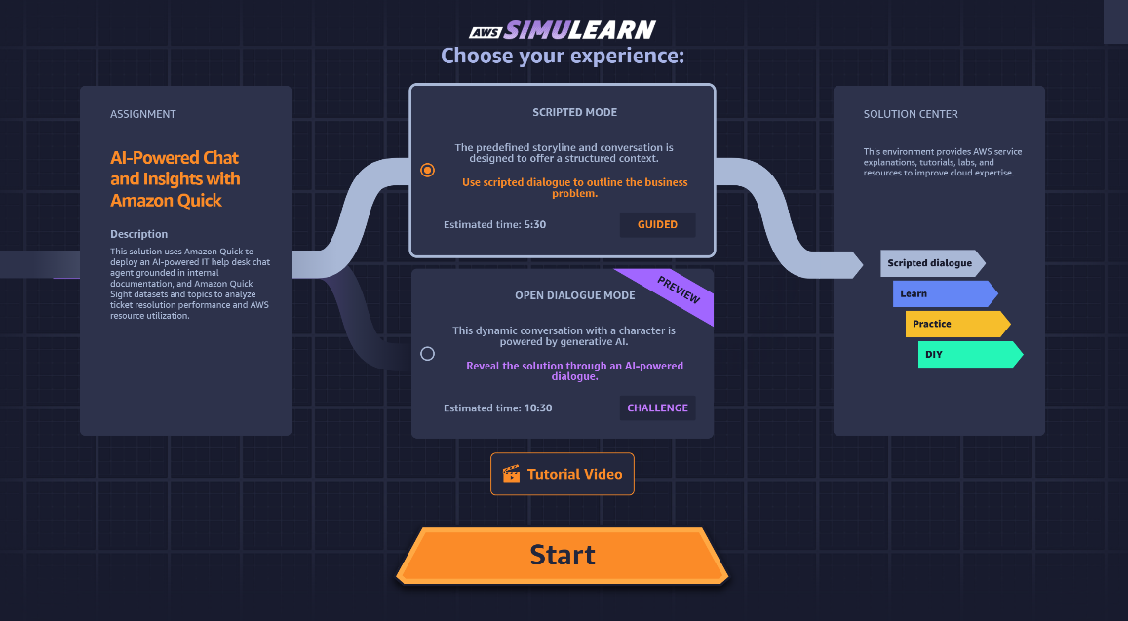
Figure 1.1: AWS SimuLearn Home Screen
The AWS SimuLearn home screen displays the AI-Powered Chat and Insights with Amazon Quick activity and provides access to the guided and DIY implementation environment.

2. Course Completion Certificate
AWS Training and Certification courses were completed to gain additional knowledge about Amazon S3, Amazon Quick, analytics and enterprise cloud solutions.
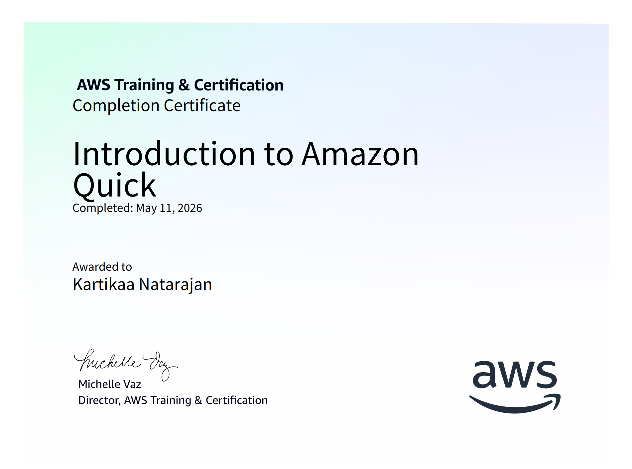
Figure 2.2: Introduction to Amazon Quick Certificate
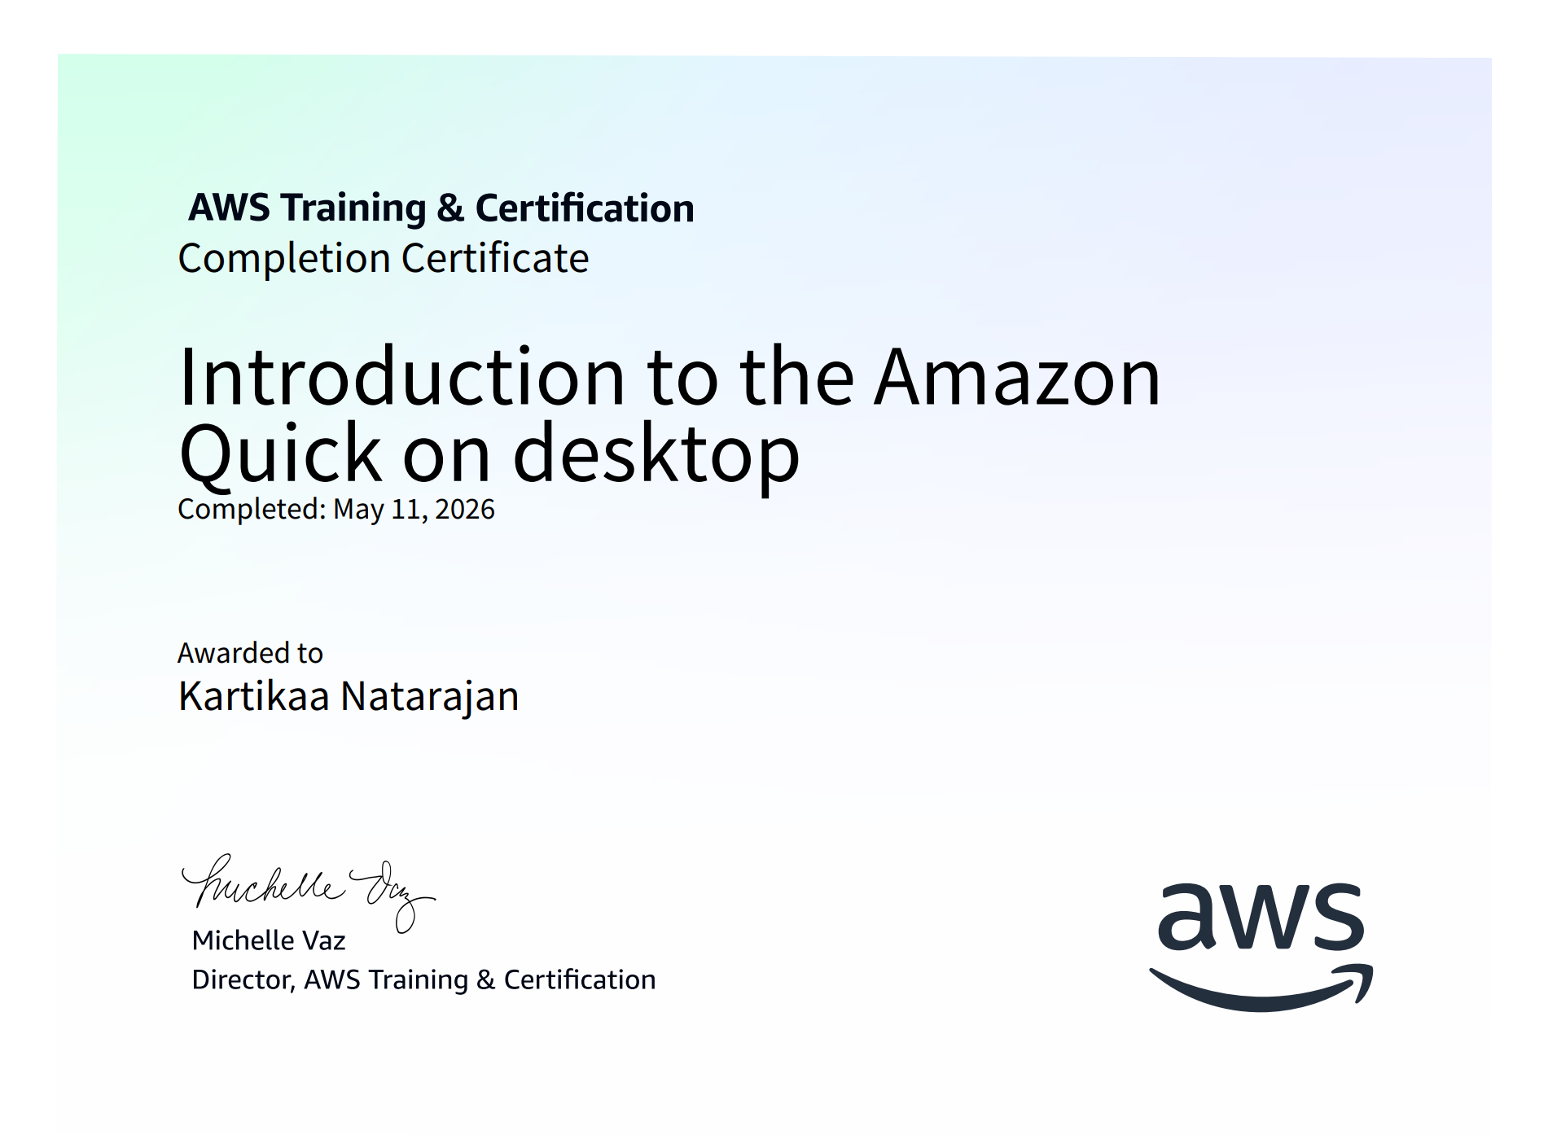
Figure 2.3: Introduction to Amazon Quick on Desktop Certificate
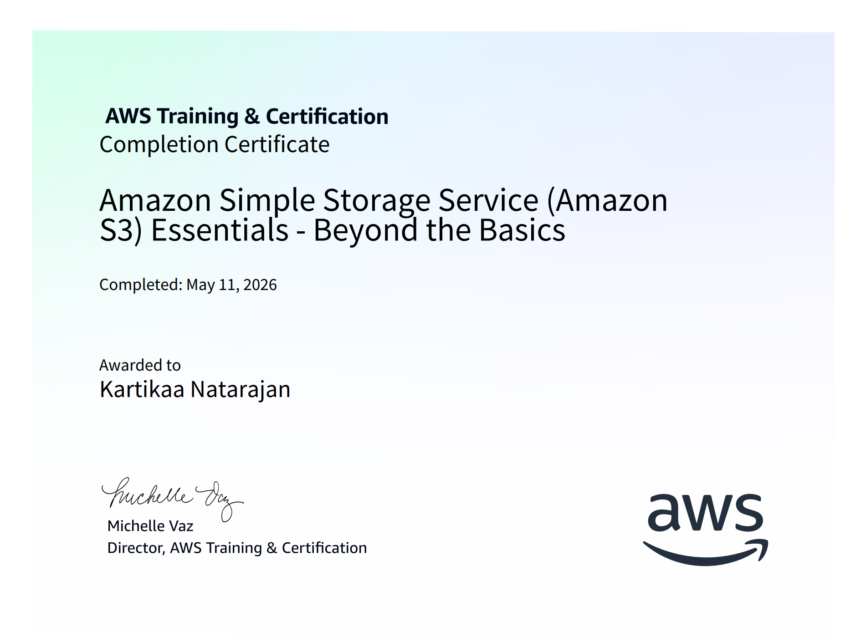
Figure 2.4: Amazon S3 Essentials – Beyond the Basics Certificate

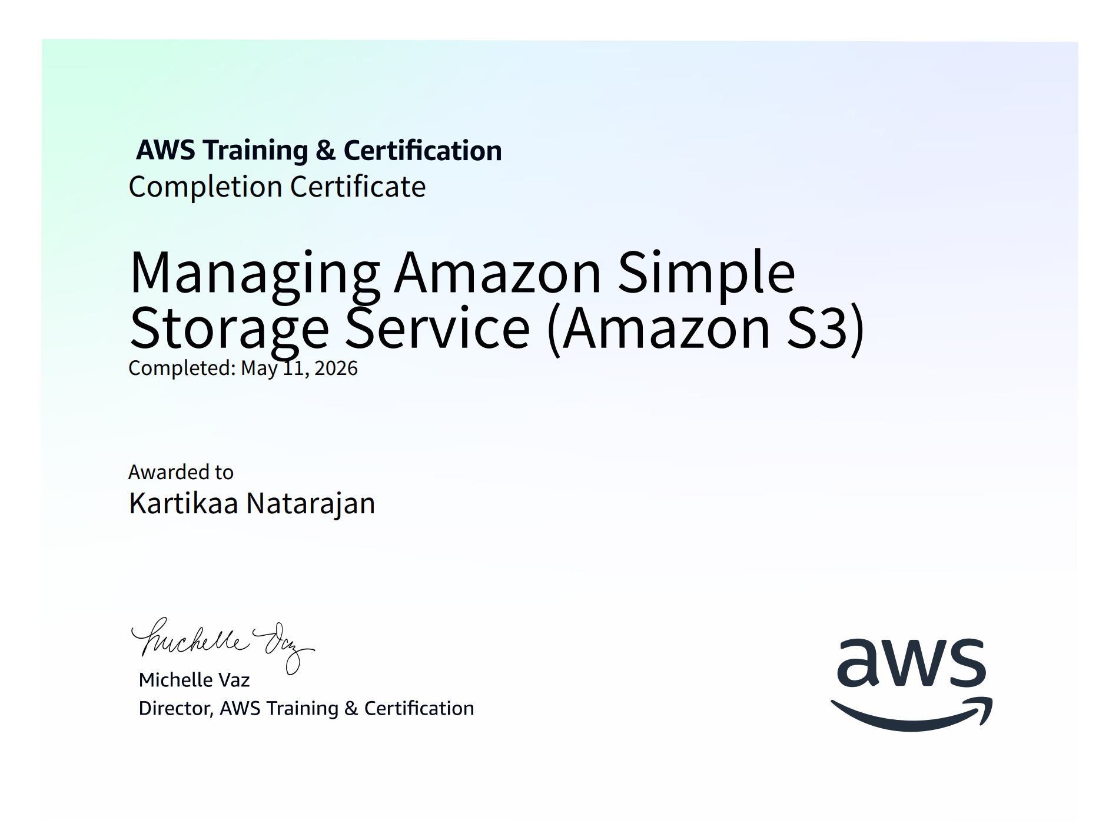
Figure 2.5: Managing Amazon S3 Certificate

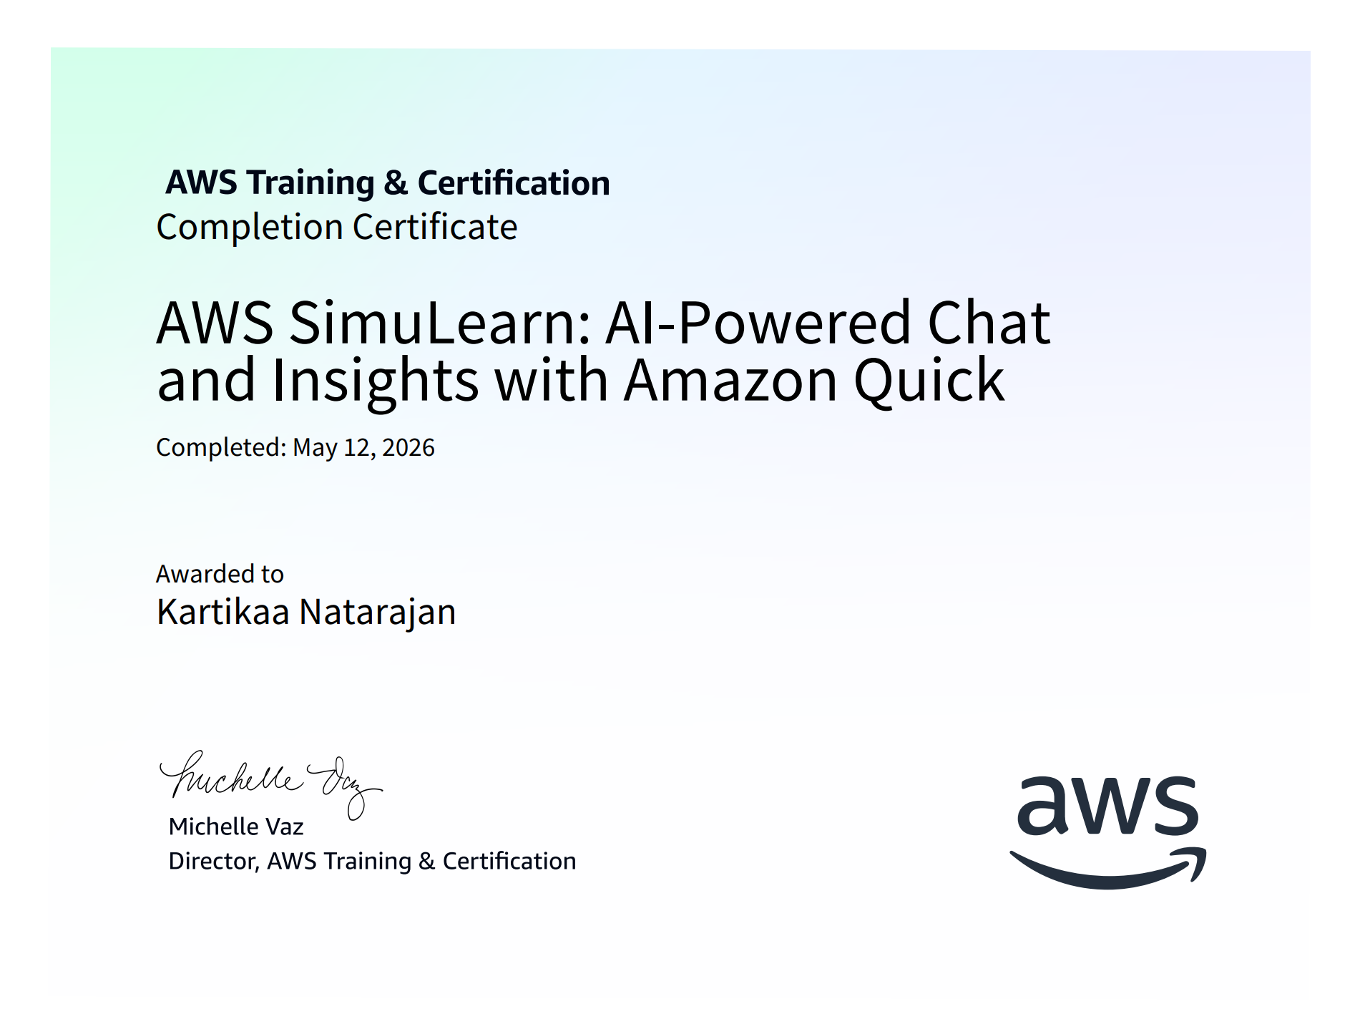

Figure 2.6: AWS SimuLearn AI-Powered Chat and Insights with Amazon Quick Certificate

3. Project Summary
A. Problem Statement
AnyCompany’s IT help desk faced major challenges due to repetitive support tickets and scattered technical documentation. Around 60% of support requests involved basic queries that employees could resolve independently if information were easily accessible.
Support staff spent nearly 40% of their time searching across disconnected systems instead of resolving complex issues. Additionally, employees working across multiple time zones lacked after-hours support access.
The organization required an AI-powered support solution capable of providing accurate answers instantly using enterprise documentation while also enabling analytics and operational insights.
B. Architecture
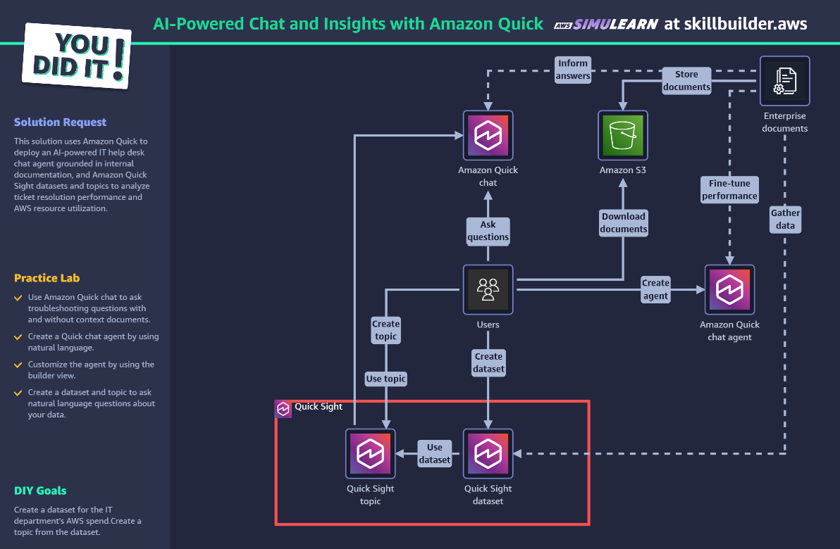
Figure 3.1: Architecture Diagram of AI-Powered Help Desk Solution

Explanation
The solution architecture integrates Amazon Q, Amazon S3, and Amazon QuickSight to provide centralized documentation storage, AI-powered employee assistance, and analytical insights.
Enterprise documents are stored in Amazon S3. Amazon Q chat agent retrieves information from the stored documentation and provides intelligent responses to users. Amazon QuickSight datasets and topics are used for analytics and AWS spend analysis.

C. AWS Services Used
AWS Service | Purpose
Amazon Q | AI-powered conversational assistant
Amazon S3 | Centralized document storage
Amazon QuickSight | Dataset creation and analytics
AWS SimuLearn | Interactive cloud learning environment

D. Steps of Implementation
Step 1: Launching AWS SimuLearn
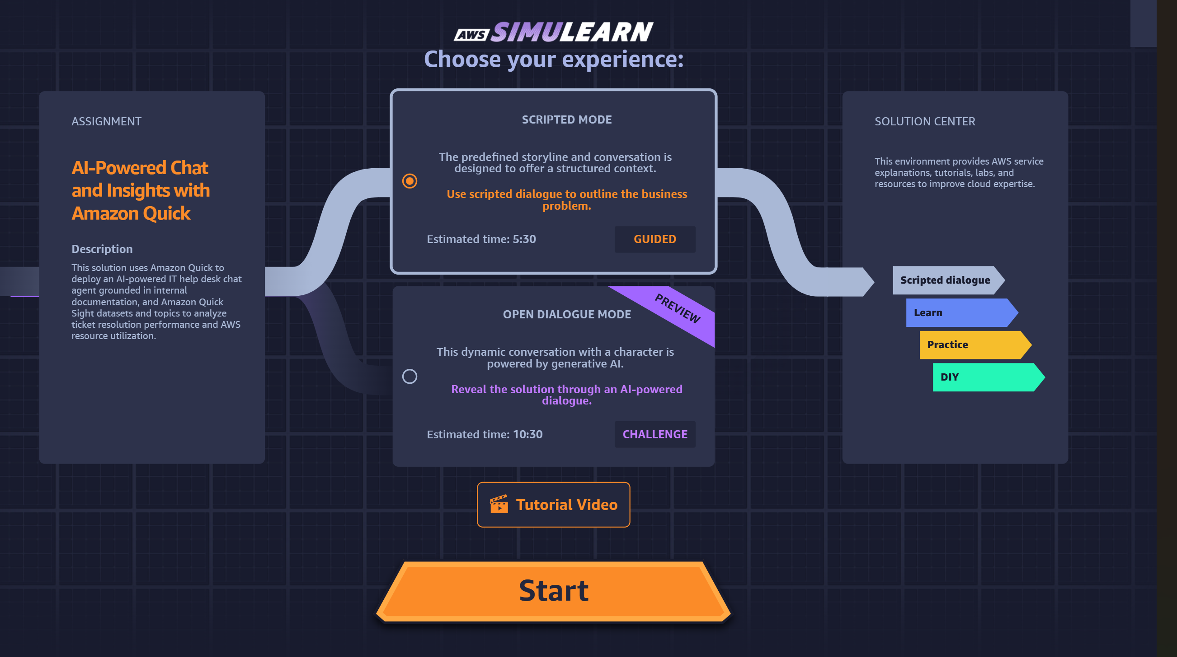
Figure 3.2: Launching AWS SimuLearn Activity
Explanation
The AWS SimuLearn environment was launched to perform the AI-powered help desk implementation activity.

Step 2: Selecting DIY Mode
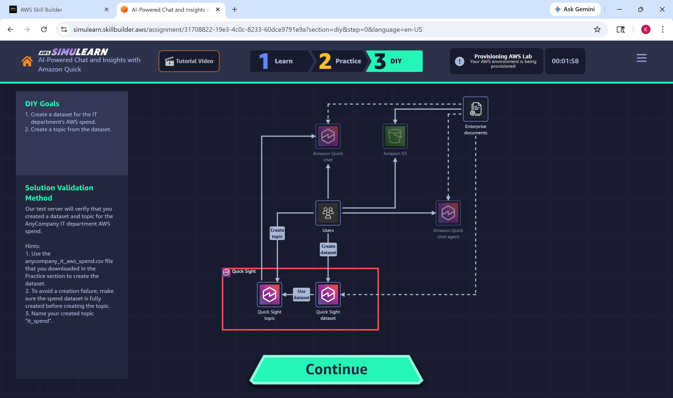
Figure 3.3: DIY Mode Selection
Explanation
DIY mode was selected to manually analyze business requirements and implement the AWS cloud solution.

Step 3: Requirement Gathering
Explanation
Business requirements were analyzed through interaction with the simulated client environment. The organization required centralized documentation access, AI-powered support, and analytics capabilities.
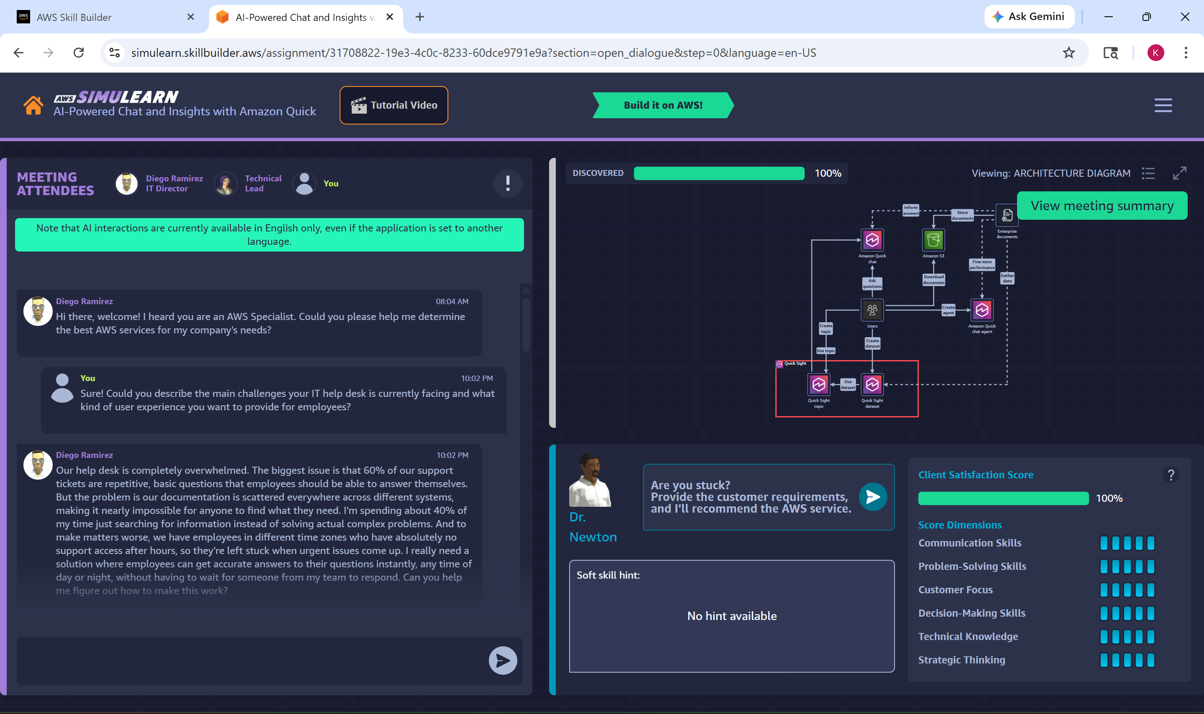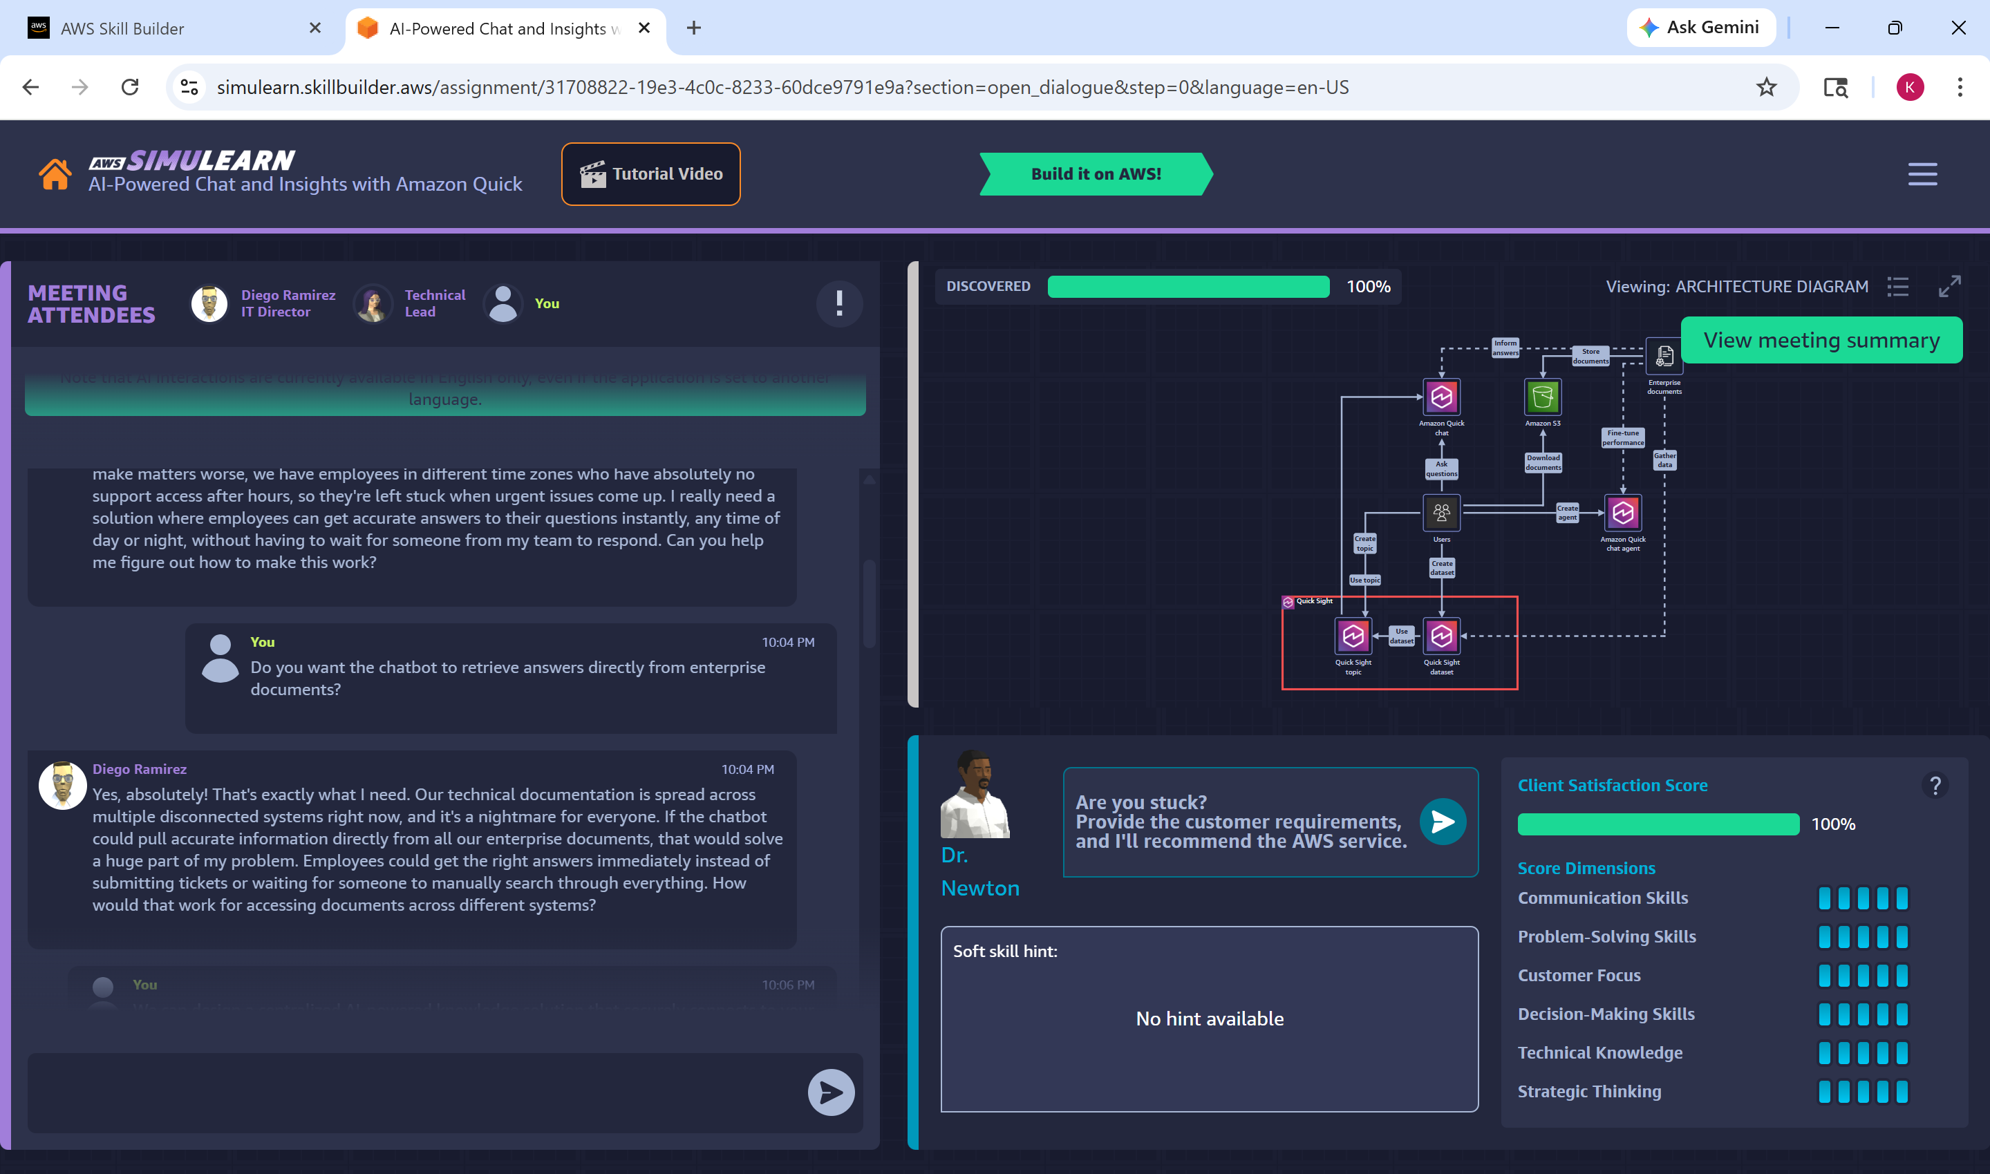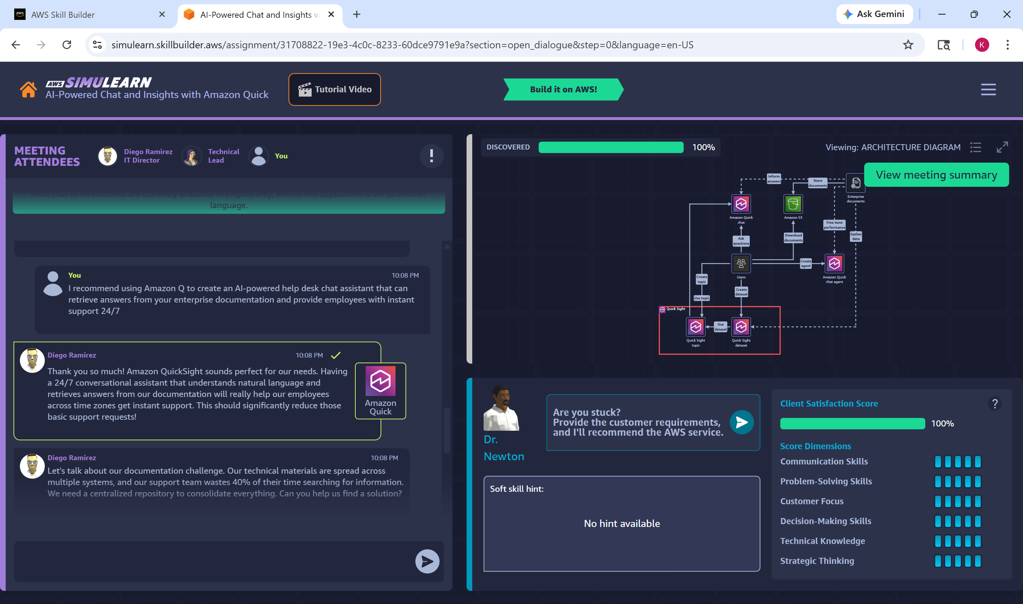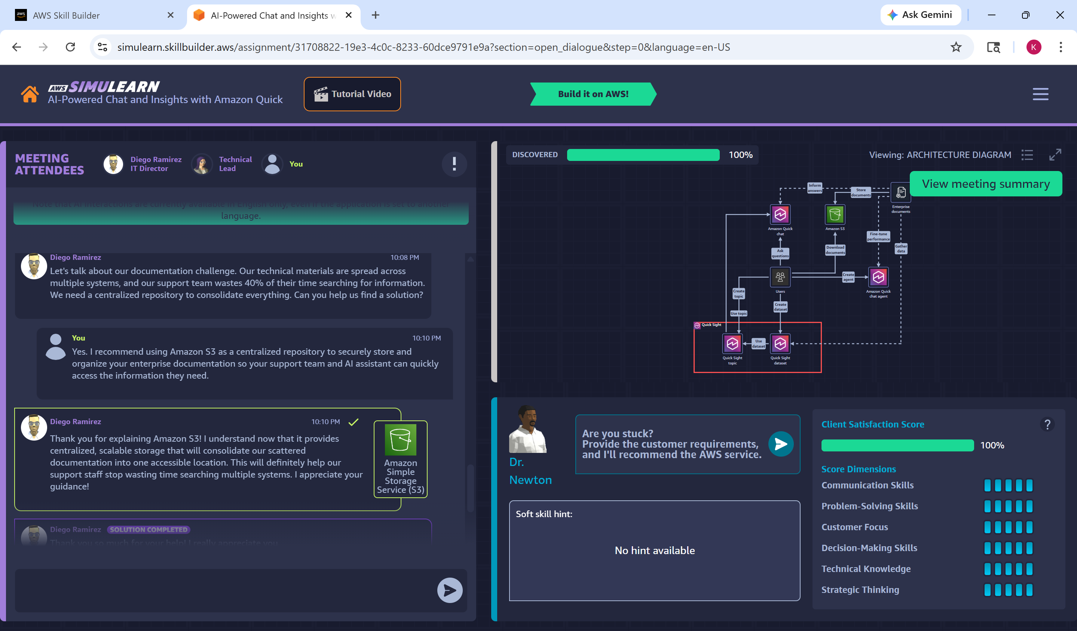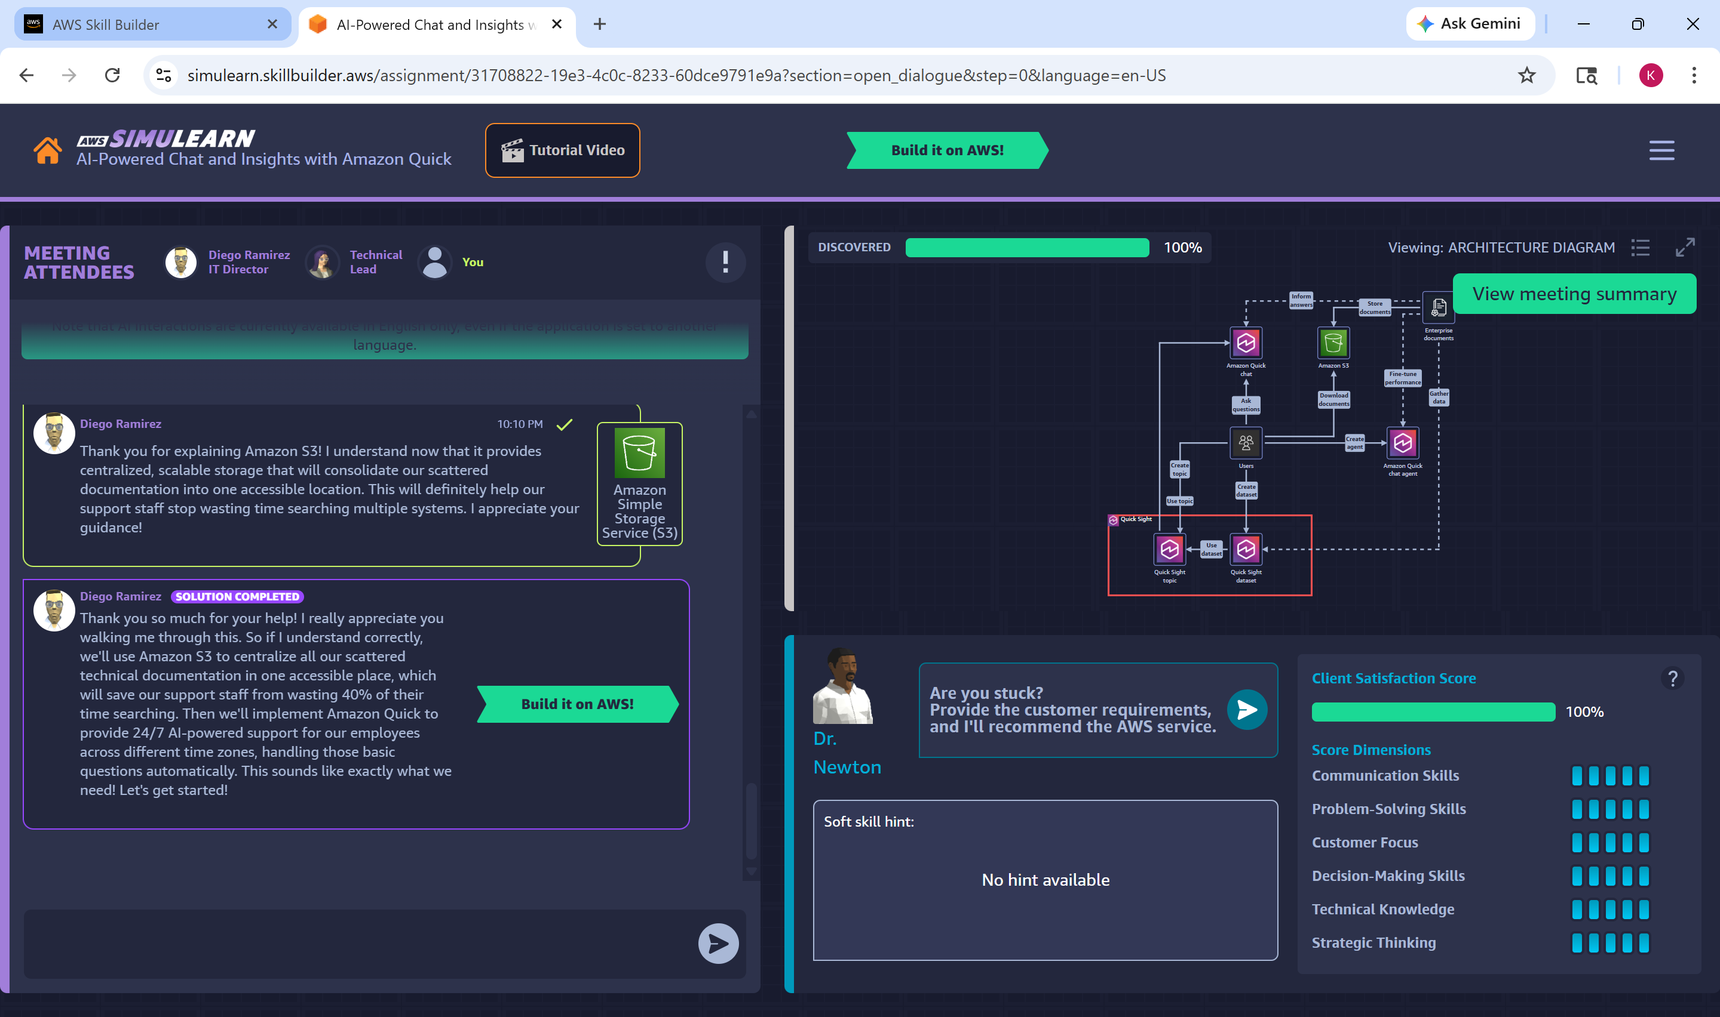
Figure 3.4: Requirement Gathering Conversation

Step 5: Opening Amazon QuickSight
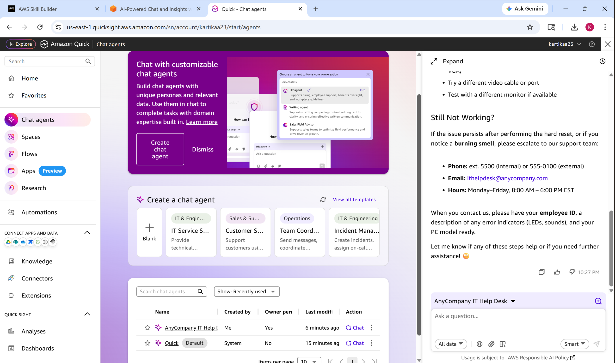
Figure 3.6: Amazon QuickSight Console
Explanation
Amazon QuickSight was opened through the AWS Management Console to create datasets and analytics topics.

Step 6: Creating Dataset in Amazon QuickSight
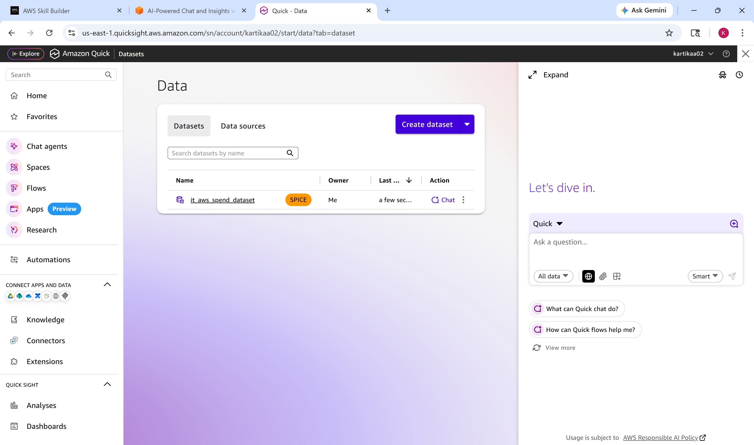
Figure 3.7: Dataset Creation in Amazon QuickSight
Explanation
A dataset named it_aws_spend_dataset was created in Amazon QuickSight using the provided CSV file for AWS spend analysis.
Step 7: Creating Topic in Amazon QuickSight
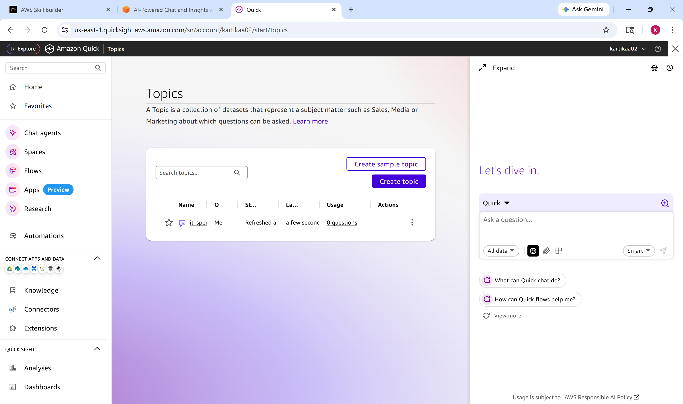
Figure 3.8: Topic Creation in Amazon QuickSight

Explanation
A topic named it_spend was created using the dataset to enable analytics and intelligent querying capabilities.

Step 8: Validation and Completion
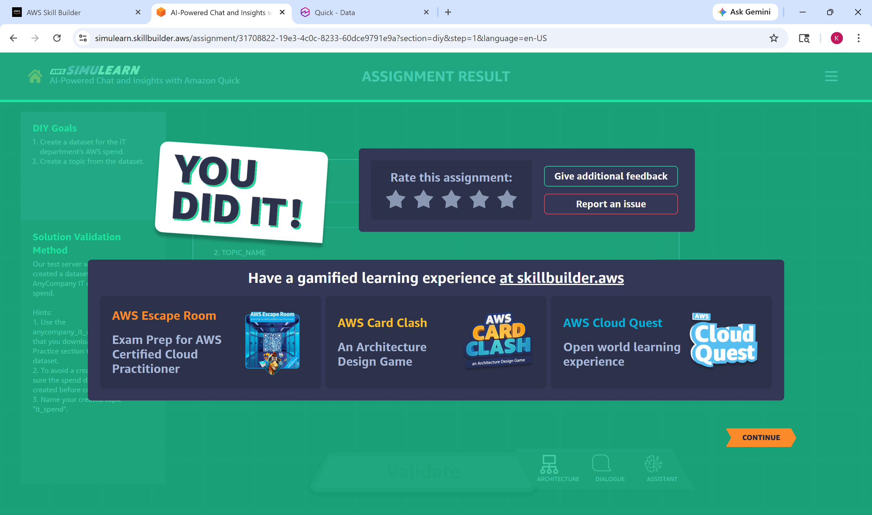
Figure 3.9: Successful Validation and Completion

Explanation
The AWS SimuLearn platform successfully validated the created dataset and topic, confirming successful implementation of the AI-powered help desk solution.

E. Output
The AI-powered IT help desk solution was successfully implemented and validated using AWS cloud services. The system demonstrated centralized document storage, AI-powered employee assistance and analytics integration using Amazon Q, Amazon S3 and Amazon QuickSight.
The activity also demonstrated how organizations can reduce repetitive support tickets and improve employee productivity through intelligent cloud-based support systems.

4. Proof Link: GitHub
GitHub Repository Link:

5. Conclusion
The AWS SimuLearn activity “AI-Powered Chat and Insights with Amazon Quick” provided practical understanding of how AWS cloud services can be used to develop intelligent enterprise support solutions. The activity demonstrated the integration of Amazon Q, Amazon S3 and Amazon QuickSight to create an AI-powered IT help desk system capable of providing instant and accurate responses using centralized enterprise documentation.
Through this implementation, the challenges of repetitive support tickets, scattered documentation, and lack of after-hours employee assistance were effectively addressed. The solution improved accessibility to technical information, reduced manual effort for support teams and enhanced overall operational efficiency through AI-driven automation and analytics.
The hands-on implementation also provided valuable experience in requirement gathering, cloud architecture analysis, dataset creation, topic creation and AWS service integration. The supplementary AWS certification courses strengthened understanding of Amazon S3 storage management, enterprise cloud infrastructure and AI-powered analytics systems.
Overall, this activity enhanced practical knowledge of cloud computing, intelligent automation, analytics integration and enterprise AI solutions using AWS technologies.

